The Musical Alphabet

The entire musical alphabet contains 8 letters. Starting with A, we have:

A B C D E F G

We also have sharps and flats. If you lay out all 12 notes it looks like this:

A (A#/Bb) B C (C#/Db) D (D#/Eb) E F (F#/Gb) G (G#/Ab) A (A#/Bb) B C and on and on

The sharps and the flats are the same notes only in the cases above. A# is a completely different note than Ab.

Once you have this memorized, all you need to do is learn the “formula” for scales and you can figure out any key. Here is the first one that I learned, a major scale:

X + 2 + 2 + 1 + 2 + 2 + 2 + 1

So to figure out the key of “C”, I’ll show you the notes I select. The ones that are not in the key of C I put in italics:

C (C#/Db) D (D#/Eb) E F (F#/Gb) G (G#/Ab) A (A#/Bb) B C
1 2 3 4 5 6 7 (8 or 1)
1 2 3 4 5 6 7 8 9 10 11 12 13 or 1
1 + 2 = 3, 3 + 2 = 5, 5 + 1 = 6, 6 + 2 = 8, 8 + 2=10, 10+2=12, 12+1 = 13 or 1

Most musicians will talk about the notes of a major scale like this 1 2 3 4 5 6 7 (8 or 1)

To play the C Major scale on a guitar, use the pattern below starting on the 8th fret of the low E, which would be a C. To play the next two notes, D and E, play the 10th and 12th fret on the same string, then for the fourth note move to the 8th fret of the A string, which is an F note.

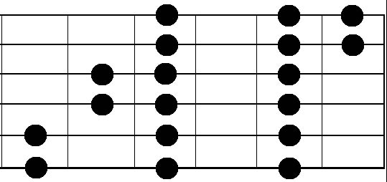
8 10 12 13

This is important to learn because this can all be applied to songwriting, making guitar solos, and above all, having fun!

©2009 (Bryan Connolly) All Rights Reserved.

